**Assignment 2 C reating a model**

[Before I start, if you don’t mind I would like to ask you the following is a good project:   
(I would like to develop and train an AI model that can identify the nutrient levels in a plant, identify humidity levels and most importantly identify the nutrients missing in the crop to help determine the farm chemiclas and fertilizers to use). 0793790005 is my number in case of feedback. Thank you sir.]

I started by creating a dataset, named it info_dataset.csv, here is the screenshot:

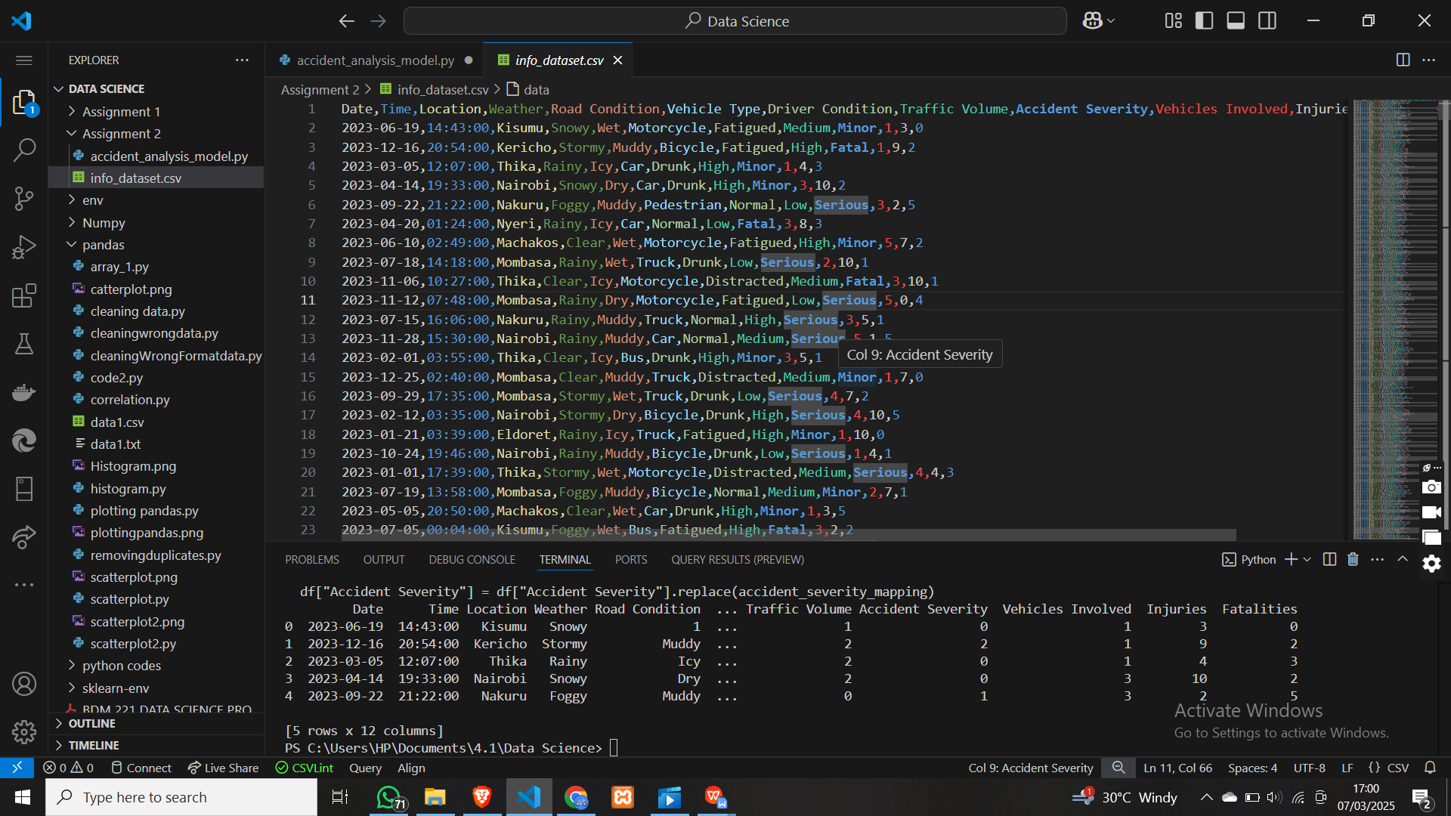

It contains the following columns: date, Time, location,. weather, road condition, vehicle type, driver condition while driving, traffic intensity, accident severity if there was any, among others. All this information is made up or collected from different datasets on the web. They are not from a single site.

I also have a main file, called accident_analysis_model.py.   
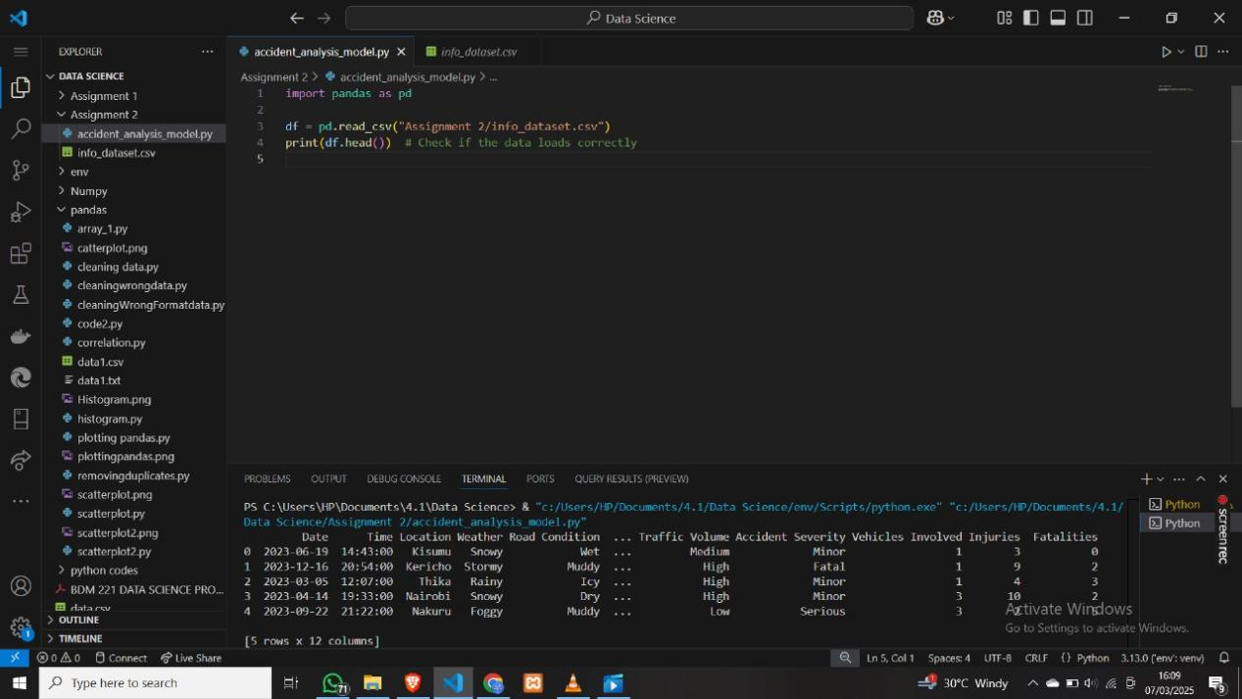

I loaded the file containing the information (info_dataset.csv).

I changed the values of the string valued values to integers  
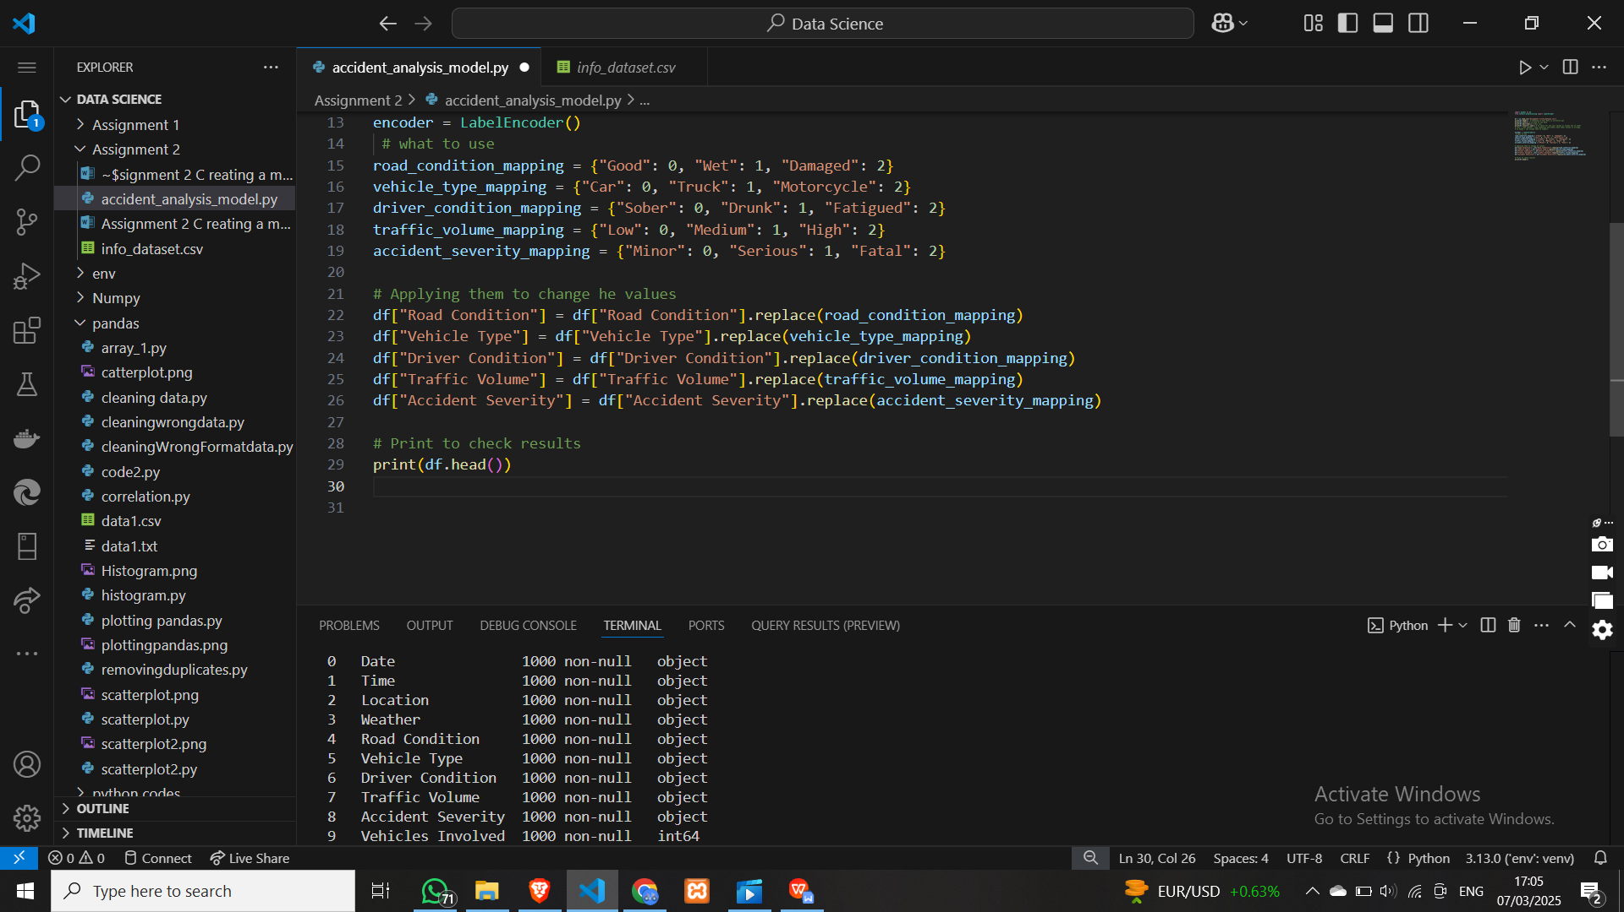

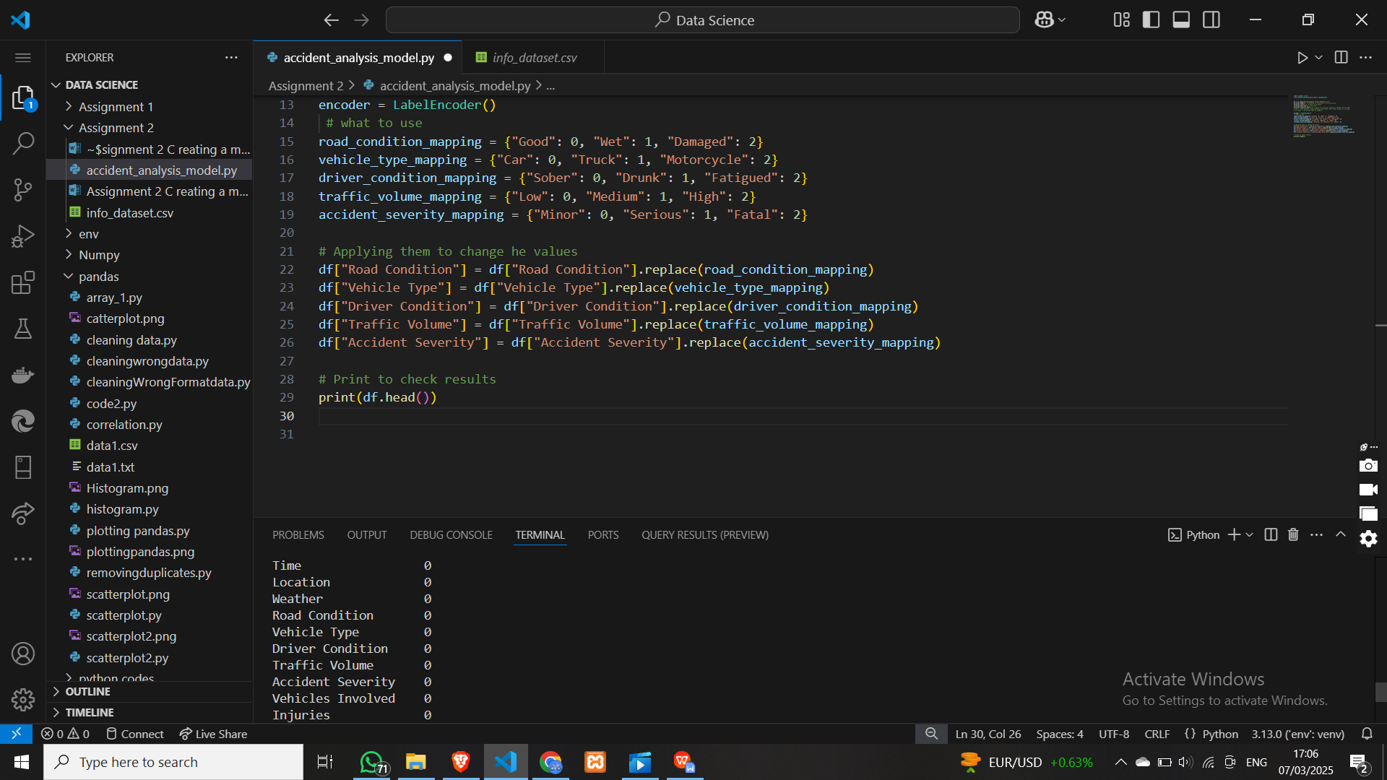

A;so updated the versions of

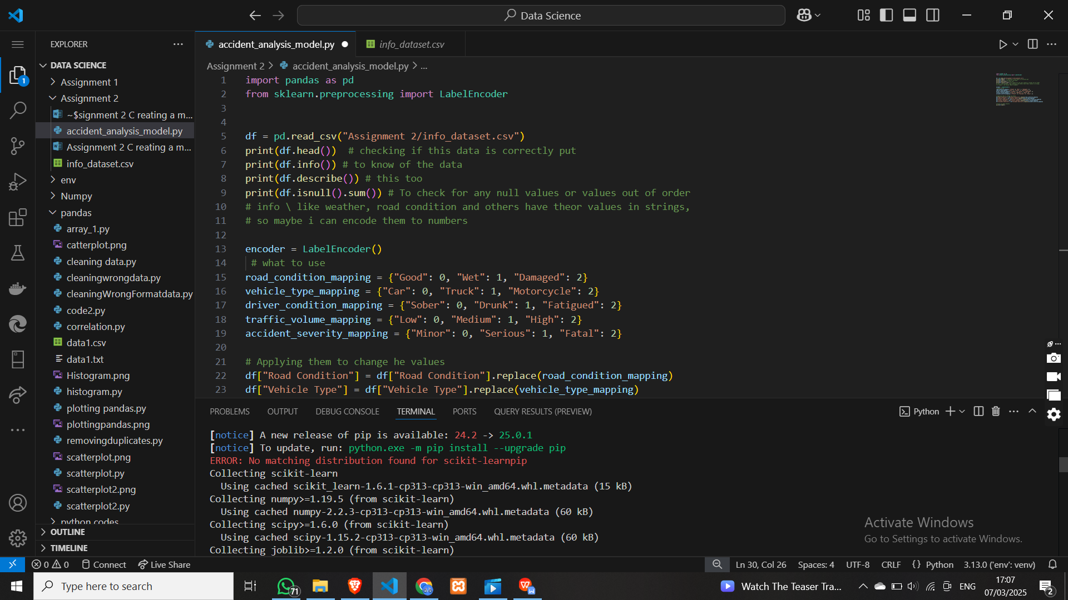

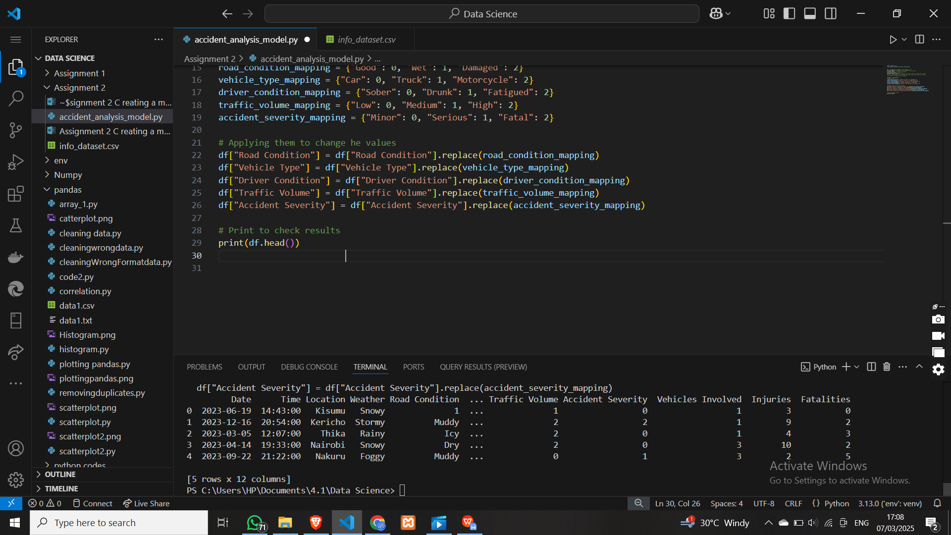

And then I try to divide thedata into 2 sets, fr training 80, and for testing 20:  
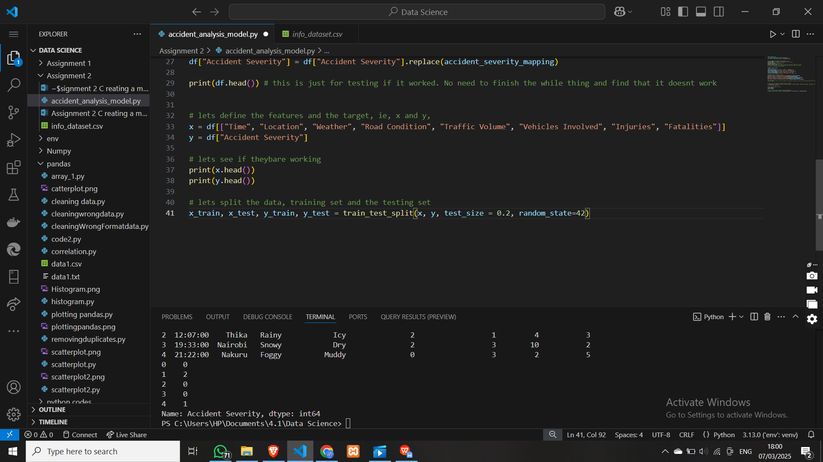

Ran it to make sure, it was alittle hard to make each go to their own line, but finally I did it.   
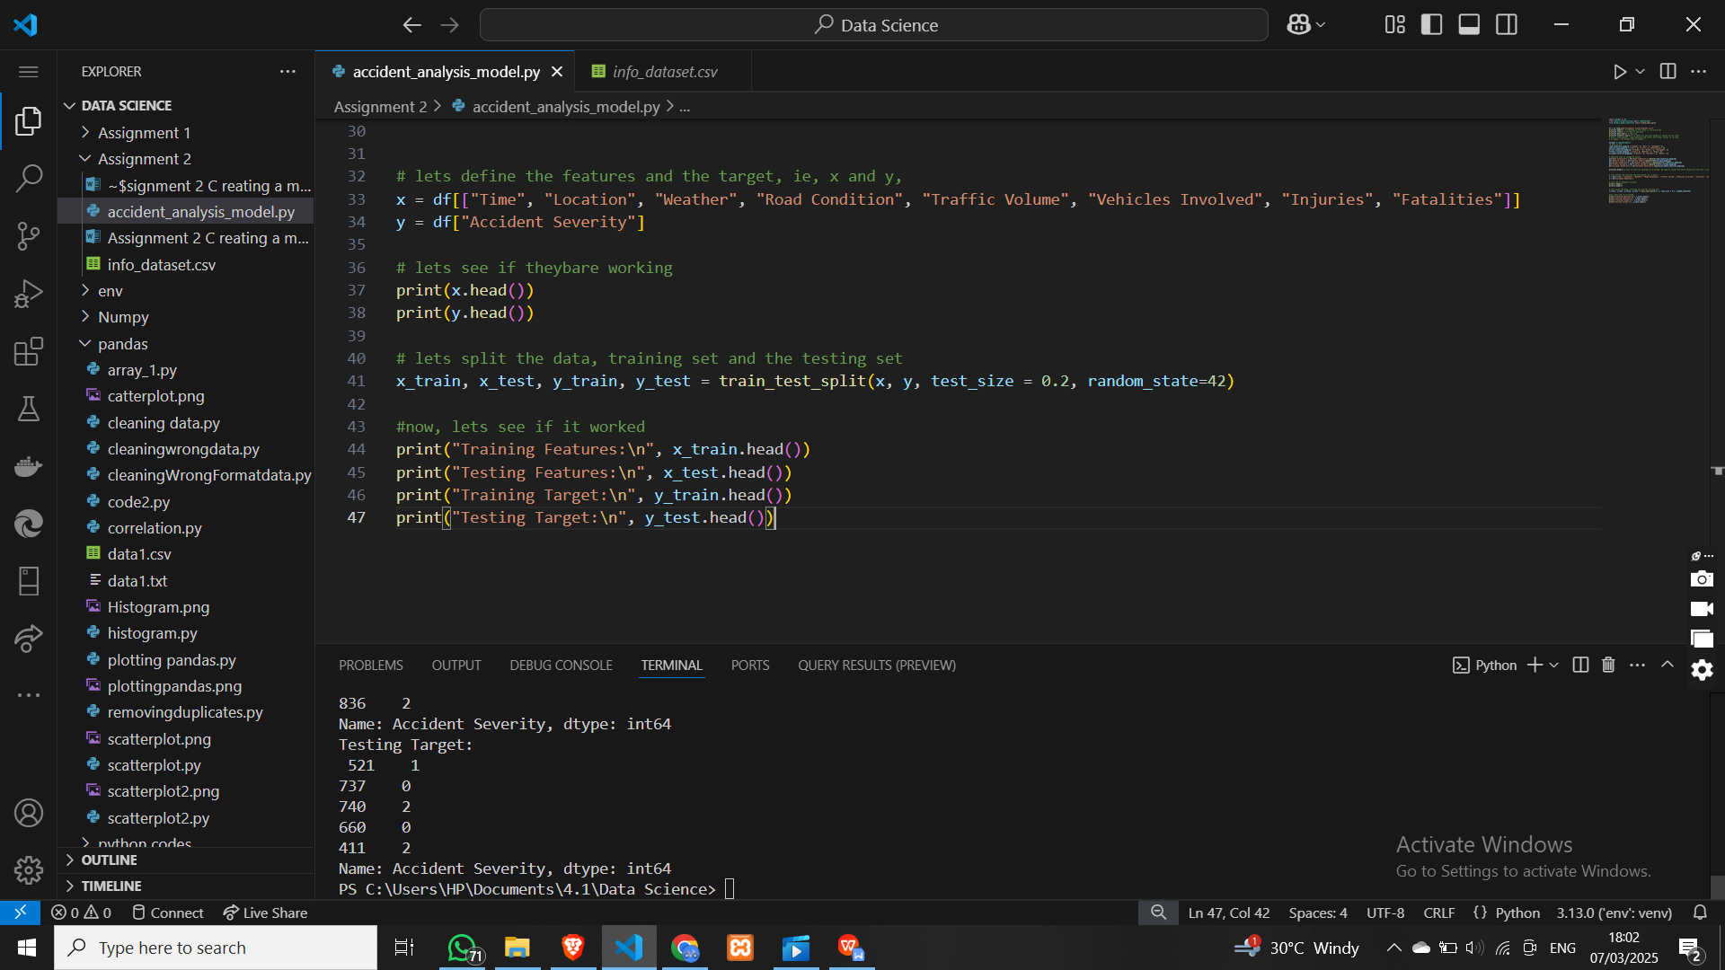

Just trying sth

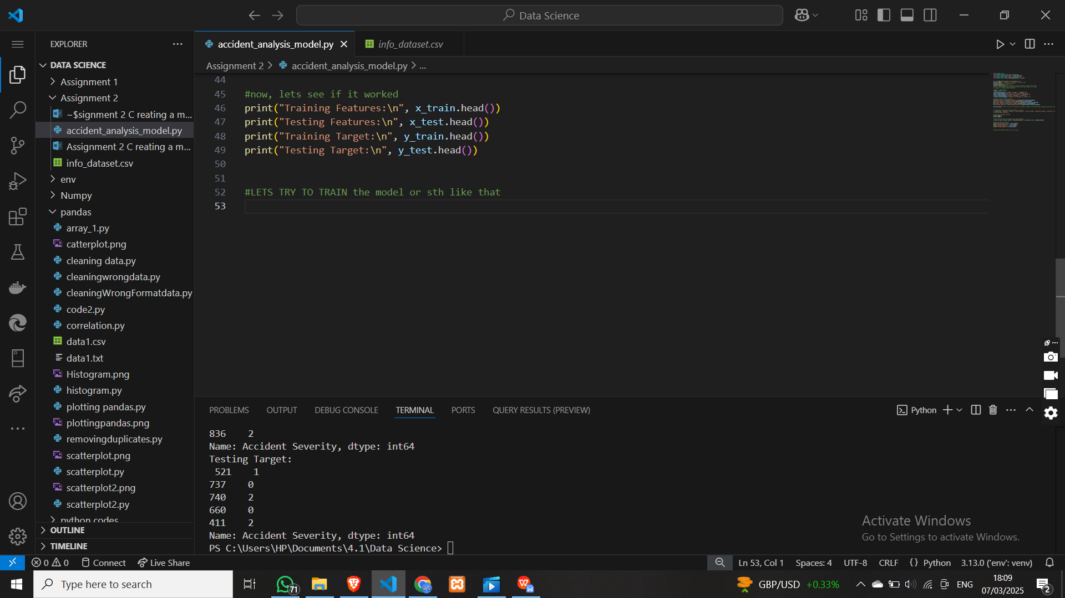

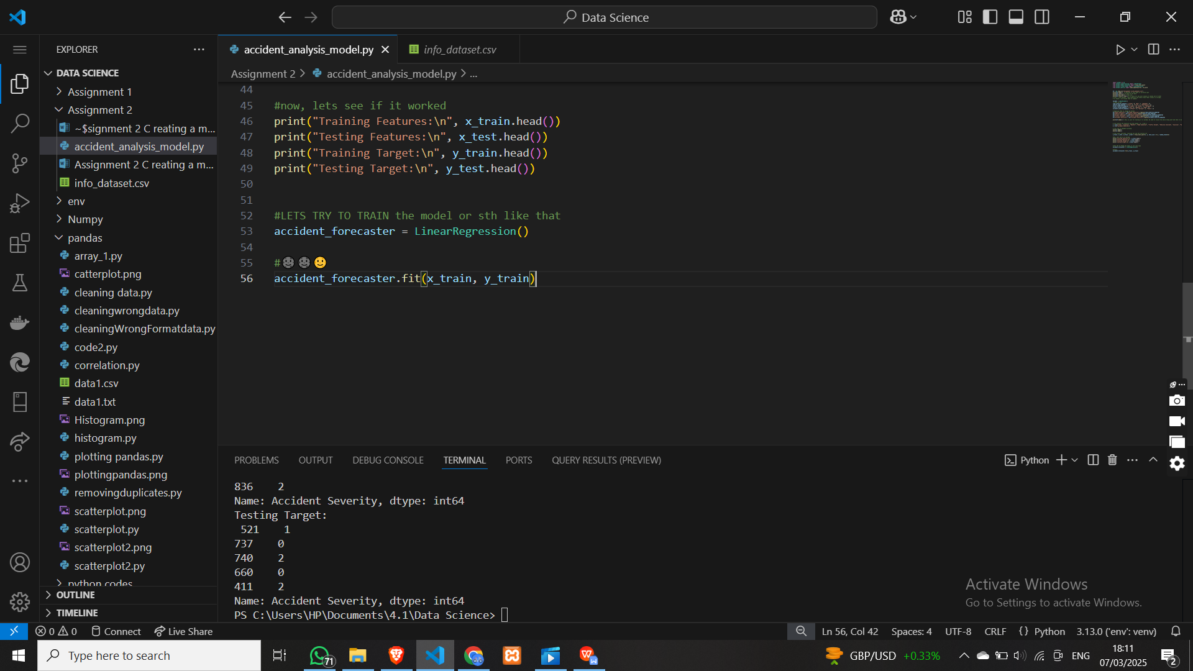

Got an error for time. I had not changed it into a numerical value

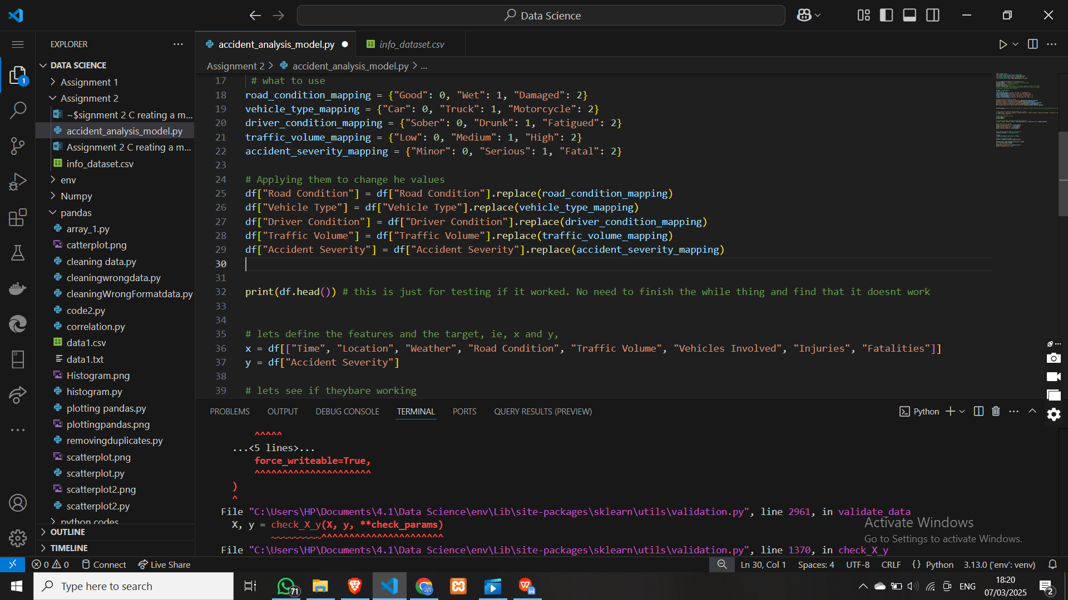

I also added a recommendations part:

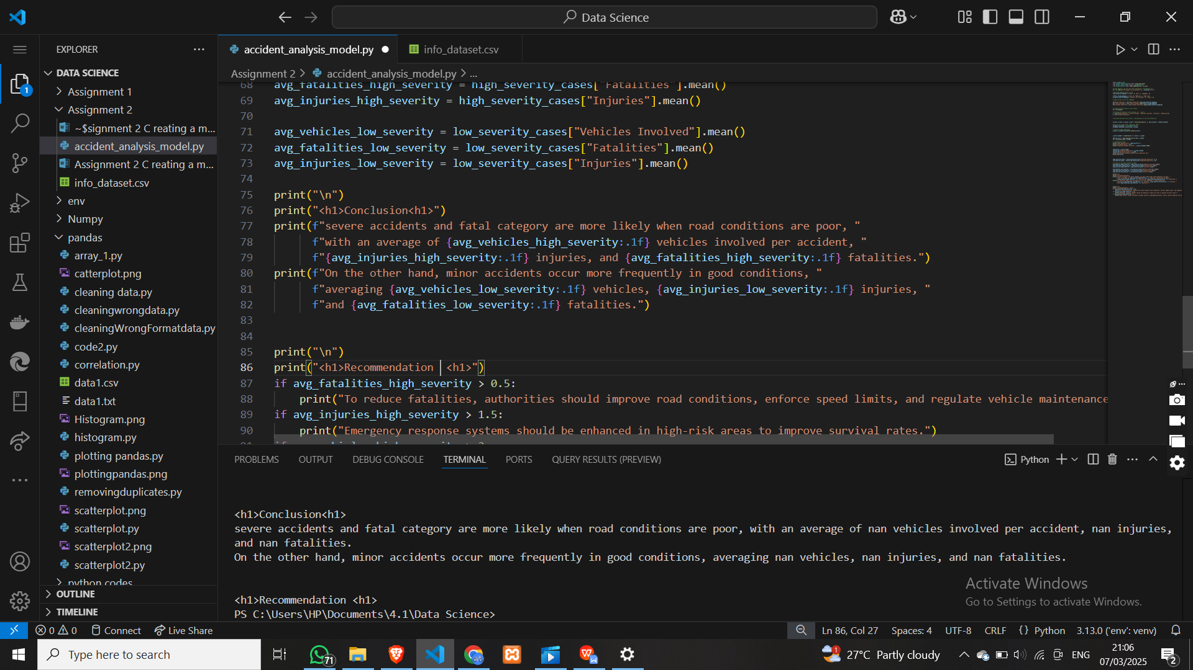

And conclusions  
